**Weekly forecasts of BA.2 outbreak in NYC**

Alex Washburne, Jay Varma, Nathaniel Hupert

**Introduction**

Policy makers and the general public benefit from knowing how much COVID-19 is currently in the community and from knowing the probability that it will either increase or decrease in the near future. In New York City, the Health Department provides both an [“alert level” based on a CDC formula and detailed data](https://www1.nyc.gov/site/doh/covid/covid-19-data.page) about cases, hospitalizations, deaths, and [COVID-like illness visits to emergency departments](https://github.com/nychealth/coronavirus-data/tree/master/trends). What’s missing, however, is an estimate of the likelihood that cases will rise to the next alert level in the City, similar to a weather forecast that predicts the likelihood of rain or snow next weekend. In contrast to forecasts about the weather, however, forecasts about COVID-19 can help change the epidemic. Knowing that there is a high risk that the City will move to the next alert level could alert individuals, organizations, or government to take actions that slow the epidemic.

We present a novel approach to forecasting COVID-19 outbreaks for New York City. Rather than rely on complex compartmental models with hidden assumptions embedded in the model structure and parameter estimates, we build our forecast on the observation that SARS-CoV-2 outbreaks from different variants of concern (including Delta and the original Omicron) have a growth rate and duration that is similar regardless of where the outbreak occurs worldwide. Consequently, our forecast for the NYC BA.2 outbreak is based on the hypothesis that the NYC outbreak will follow a trajectory similar to the UK BA.2 outbreak.

Comparative epidemiological forecasts were extremely effective at forecasting the dates when cases peaked for Delta and Omicron waves across countries (Washburne et al. 2022). In addition to providing a visually accessible forecast, our approach also allows real-time comparison of outbreaks to estimate the effectiveness of interventions and identify when outbreaks are no longer comparable. In addition to updating our forecasts regularly, we will add new data points to historical forecasts to allow real-time comparison of model performance.

**Methods**

Our forecasts rely on estimating case growth rates $r(t-t_{0})$ as a function time since an outbreak began. We estimate case growth rates from reported confirmed cases using the same methods in Washburne et al. 2021. We first remove outliers and then estimate growth rates. Time-series outliers removed using the R package *tsoutliers* using an ARIMA(p,d,q) model fit via maximum likelihood where p=1, d=1, and q=2 were selected based on the Akaike information criterion (López-de-Lacalle, 2019). Growth rates and their 95% credible intervals were estimated with the R package *KFAS* through the filtering density of a negative binomial state space model with day-of-week fixed effects (Helske, 2016).

The New York City outbreak had a consequential outlier on April 4, 2022 that we corrected manually. For weeks prior, NYC reported 0 cases on Saturdays, but on Sunday, April 3 there were 0 reported cases followed by an uncharacteristically large number of reported cases for a Monday on April 4th. Because our method for estimating growth rates relies on fixed day-of-week rates of case ascertainment and reporting, we felt this anomalous case dump was best corrected by splitting the cases on Monday April 4th into cases on Sunday, April 3 and Monday, April 4, 2022 while preserving the Sunday/Monday case ratio from the preceding four weeks.

Outbreak start-dates were identified in both the UK and NYC as the first time after February 14, 2022 when case growth rates were positive. Outbreak times are measured in units of days since the outbreak start date. The UK BA.2 outbreak is estimated to have started on March 2, 2022 and the NYC outbreak is estimated to have started 13 days later on March 15, 2022. Plotting the growth rates as a function of outbreak time, the NYC outbreak has, as of April 9, 2022, exhibited slower growth than the UK BA.2 outbreak and crossed the UK outbreak line (Figure 1). Based on the congruence of Delta and Omicron outbreak curves across regions using these same methods, we estimate the NYC trajectory to decline parallel to the UK trajectory and peaking within the UK’s 95% CIs.

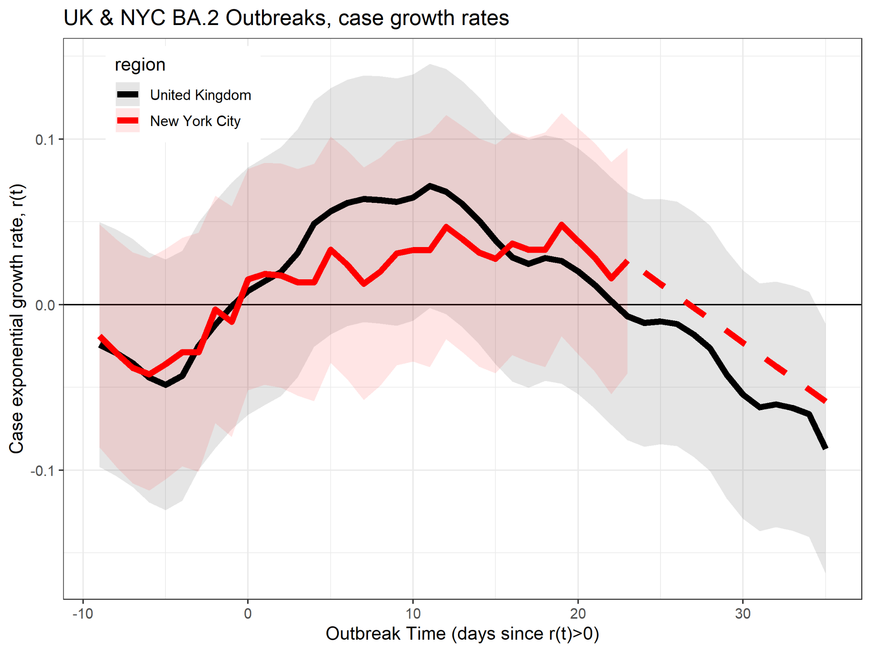

**Figure 1:** Comparison of the UK (black) and NYC (red) BA.2 outbreaks. The NYC outbreak has recently crossed the UK outbreak trajectory but began decelerations (decreases in case growth rates) shortly after crossing the UK line. Our forecast relies on the assumption that the NYC outbreak follows a trajectory parallel to its analogous outbreak in the UK (dashed red line).

**-------------------------------------------------------------------------------------------------------------------------------**

To forecast the NYC outbreak, we estimate the slope of the UK trajectory for outbreak times beyond what’s been currently observed in NYC, and we extrapolate from the latest observed growth rate of NYC along this line (Figure 2, dashed red line).

Daily updates with new case data can modify our forward-looking projections of cases and continually inform managers on the progress of the NYC outbreak relative to the precedent in the UK.

**Citations**

Helske, J. (2016). KFAS: Exponential family state space models in R. *arXiv preprint arXiv:1612.01907*.

López-de-Lacalle, J. (2019). R Package tsoutliers. In *Detection of Outliers in Time Series*.

Washburne, A. D., Hupert, N., Kogan, N., Hanage, W., & Santillana, M. (2022). Characterizing features of outbreak duration for novel SARS-CoV-2 variants of concern. *medRxiv*.

Washburne, A., Silverman, J., Lourenco, J., & Hupert, N. (2021). Analysis and visualization of epidemics on the timescale of burden: derivation and application of Epidemic Resistance Lines (ERLs) to COVID-19 outbreaks in the US. *medRxiv*.